JIRA TASK

Epic-https://gopikrishnas473.atlassian.net/browse/SCRUM-1  
  
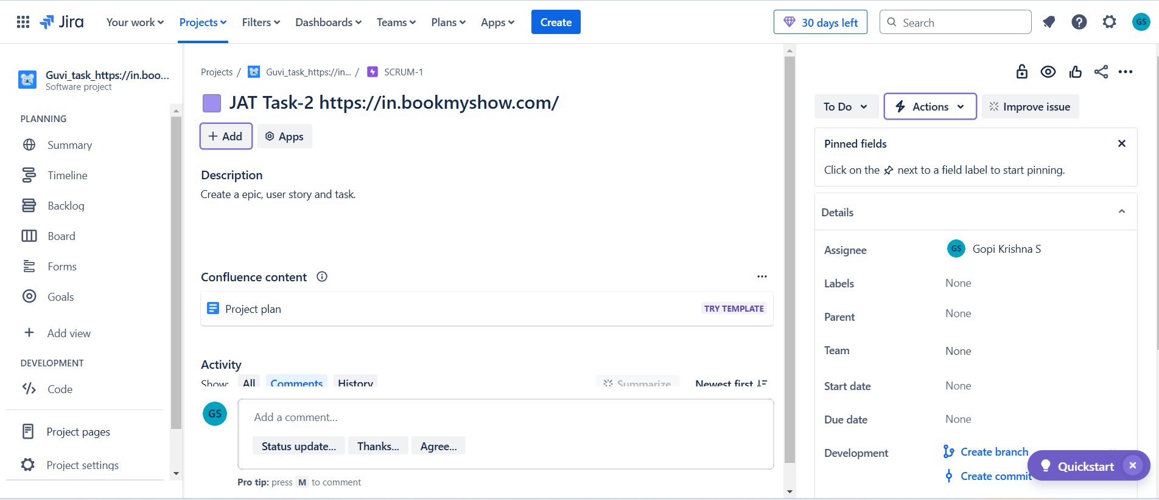  
  
Task - <https://gopikrishnas473.atlassian.net/browse/SCRUM-2>  
  
